Bahria University,

Karachi Campus



LAB EXPERIMENT NO.

___03___

LIST OF TASKS

|  |  |
| --- | --- |
| TASK NO | OBJECTIVE |
| **01** | Display Product Name and its Category Name where Category Name starts with B (Hint: Left join category and product, use wild card) |
| **02** | Display Titles and their quantity (Hint Pubs database, table title and sales, left join). |
| **03** | Use Right join to display Book Title and publisher Names (Hint pubs Database, Table Title and Publisher) Write down the reason for any null values if coming in title column. |
| **04** | User Right join to display those publishers where title is null. |
| **05** | Use self-join to display Publishers name where city is same (Publisher id should be different) Sample example |
| 06 | Use cross join (Cartesian join) to Display Book Title and Publisher Name. |

Submitted On:

22-03-2023

(Date: DD/MM/YY)

**Task 01:** Display Product Name and its Category Name where Category Name starts with B (Hint: Left join category and product, use wild card)

**Solution:** select ProductName,CategoryName from Categories left join Products on

Categories.CategoryID=Products.CategoryID

where Categories.CategoryName like 'B%'

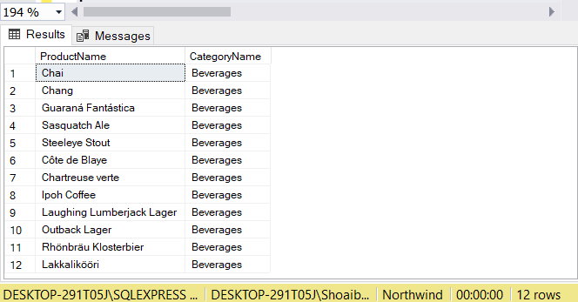**Output:**

**Task 02:** Display Titles and their quantity (Hint Pubs database, table title and sales, left join)

**Solution:** select title,qty from titles left join sales on titles.title_id=sales.title_id

**Output:**

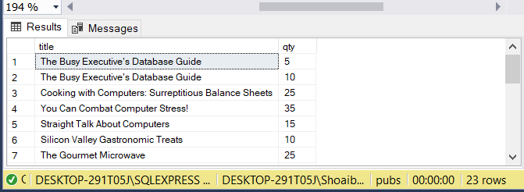

**Task 03:** Use Right join to display Book Title and publisher Names (Hint pubs Database, Table Title and Publisher) Write down the reason for any null values if coming in title column.

**Solution:** select A.title,B.pub_name from titles as A right join publishers as B on

A.pub_id=b.pub_id

**Reason**

The reason is that we wrote right join so the whole column are fetched from publishers as well as the pub_id is same in both tables then they all are fetched but the whole column is fetched in publishers table because of right join and null values is written in front of publishers column because of no same value (pub_id) in other (titles) table.

**Output:**

**Task 04:** User Right join to display those publishers where title is null.

**Solution:** select title,pub_name from titles right join publishers on titles.pub_id=publishers.pub_id where titles.title is null

**Output:**

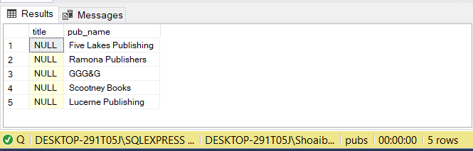

**Task No. 5:** Use self-join to display Publishers name where city is same (Publisher id should be different) Sample example

**Solution:**

select a.pub_name,b.pub_name ,b.country from publishers a,publishers b where a.country=b.country and a.pub_id<>b.pub_id

**Output:**

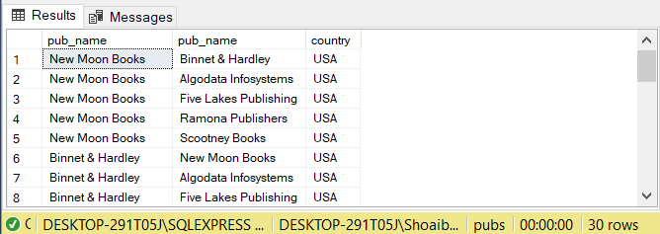

**Task No. 6:** Use cross join (Cartesian join) to Display Book Title and Publisher Name.

**Solution:** select a.pub_name,b.title from publishers as a, titles as b

**Output:**

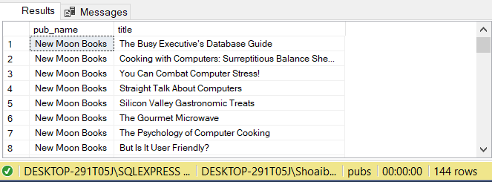

**Task No. 7:** Use two full joins to Display Product Name, Category Name and Supplier Name (Hint: Below Example)

**Solution:** select ProductName,CategoryName,ContactName from Products full join Categories

on Products.CategoryID=Categories.CategoryID full join Suppliers on

Suppliers.SupplierID=Products.SupplierID

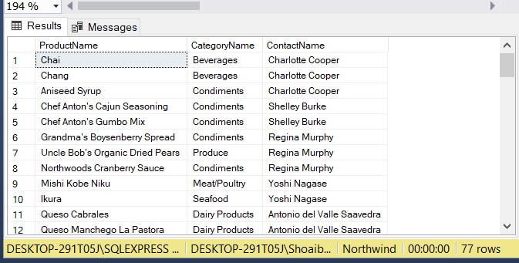**Output:**

**Task No. 8:** Use full join to display the name of Supplier for the product starting with letter C (Hint: Northwind)

**Solution:**

select ProductName,ContactName from Products full join Suppliers on Products.SupplierID=Suppliers.SupplierID where ProductName like 'C%'

**Output:**

**Task No. 9:** Get shipper’s Company Name for an order using inner join. (Display only orderID from orders and comapnayName from Customers table)

**Solution:**

select Orders.OrderID, CompanyName from Customers inner join Orders on

Orders.CustomerID=Customers.CustomerID

**Output:**

